**Unit 10 Recitation Activities**

**9-3 From the Unit Circle to the Function Graph**

How does the tangent of an angle relate to the unit circle geometrically?

**Yoshiwara Trigonometry**

**4.2 Review #2:**

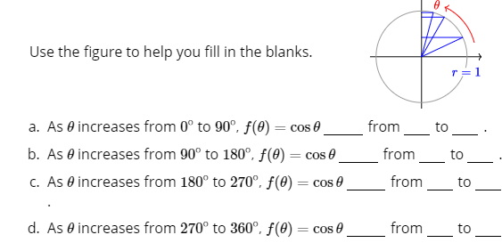

**4.2 Review #4;**



**4.2 HW #32:**

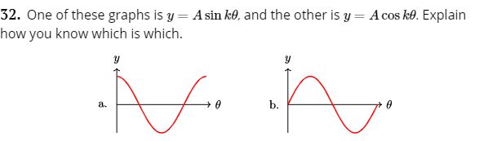

**4.2 HW #42**

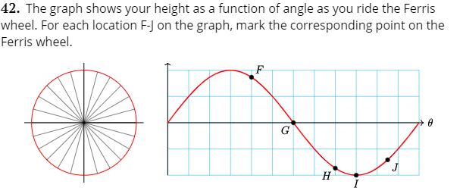

**4.2 HW #65-68**

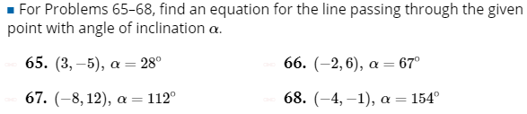

**4.2 HW #61-64 (Instead, find all trig functions of the angle of inclination)**

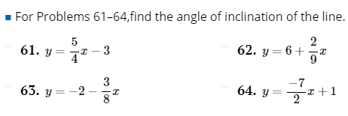

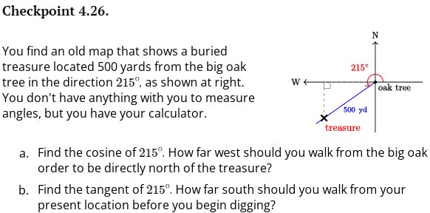

**FM 9.1:**



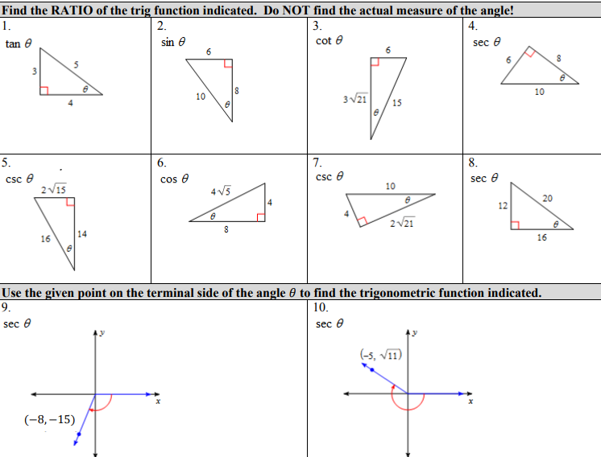

**APC 4.4:**

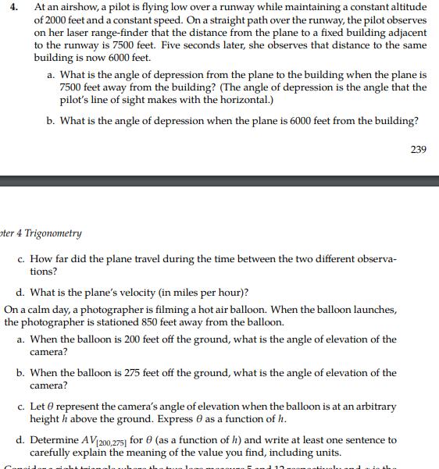

**APC 4.3**

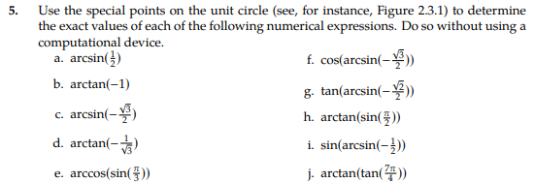

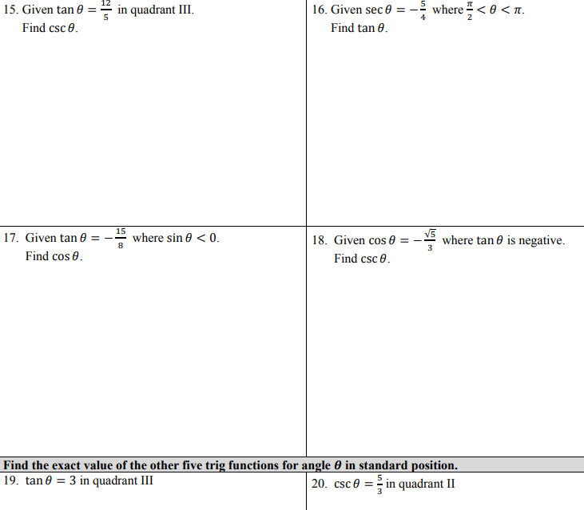

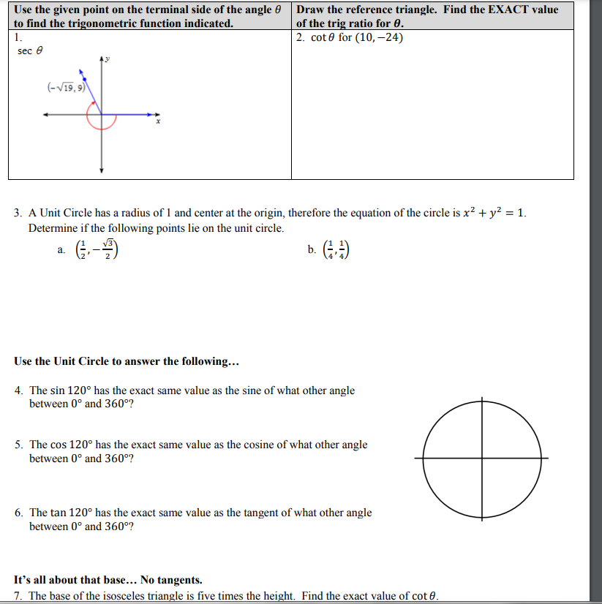

**FM 9.2:**

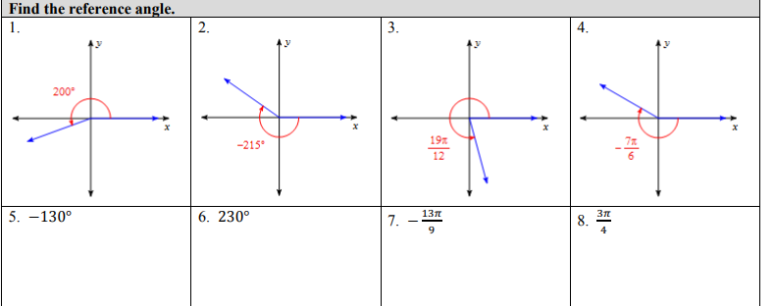

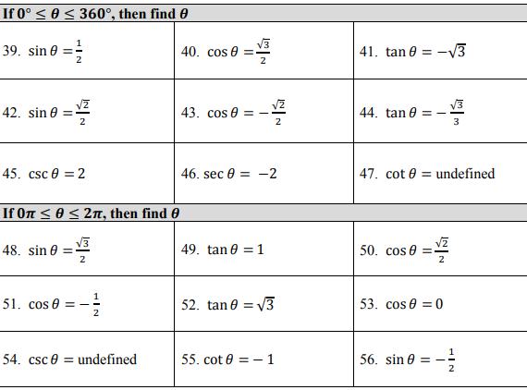

**S-Z 10.2:**

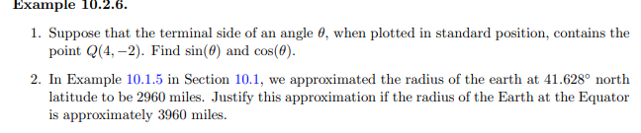

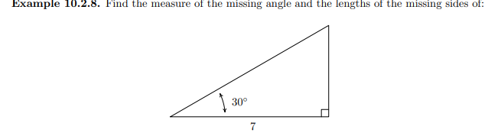

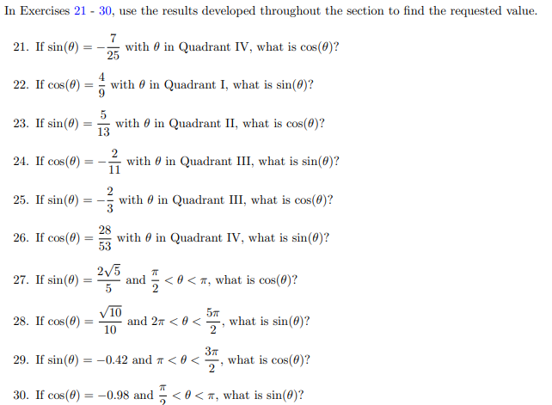

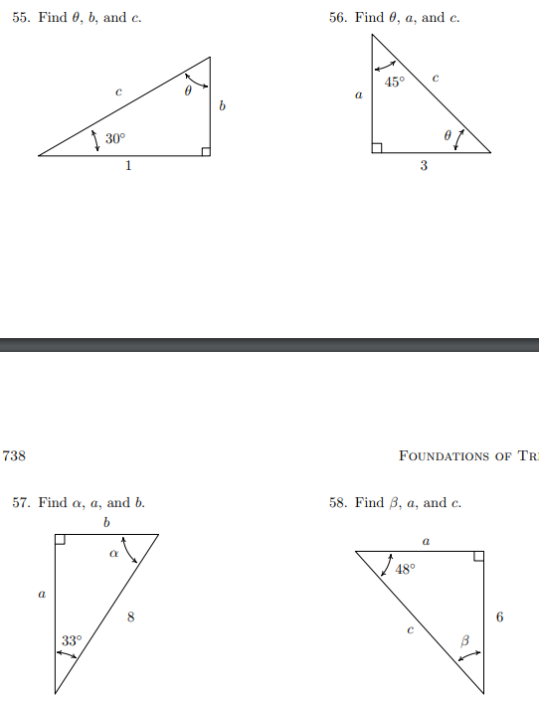

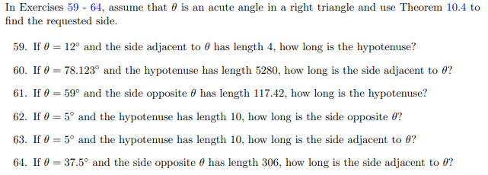

**Oct. 20:**

**MFG: 4.2:**

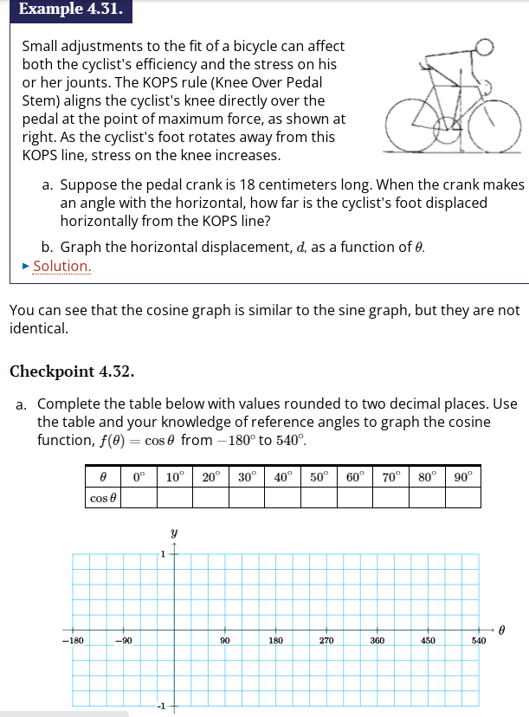

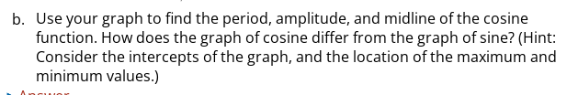

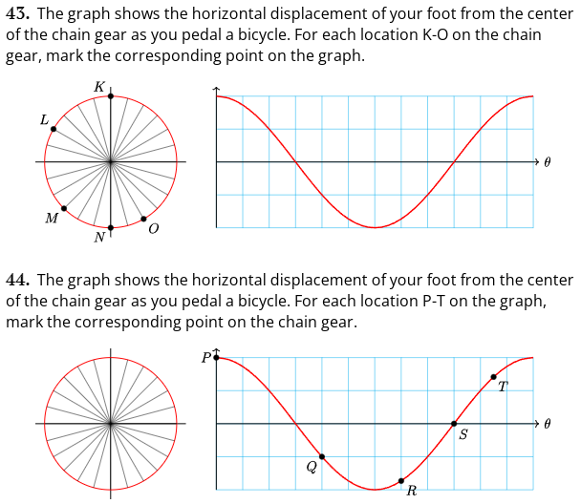

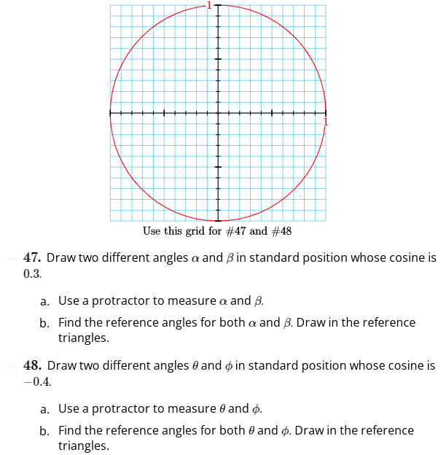

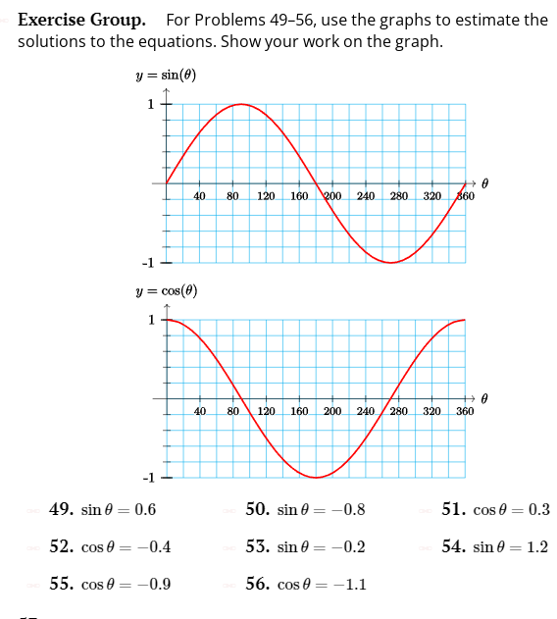

**MFG 4.4:**

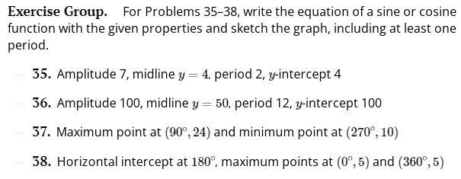

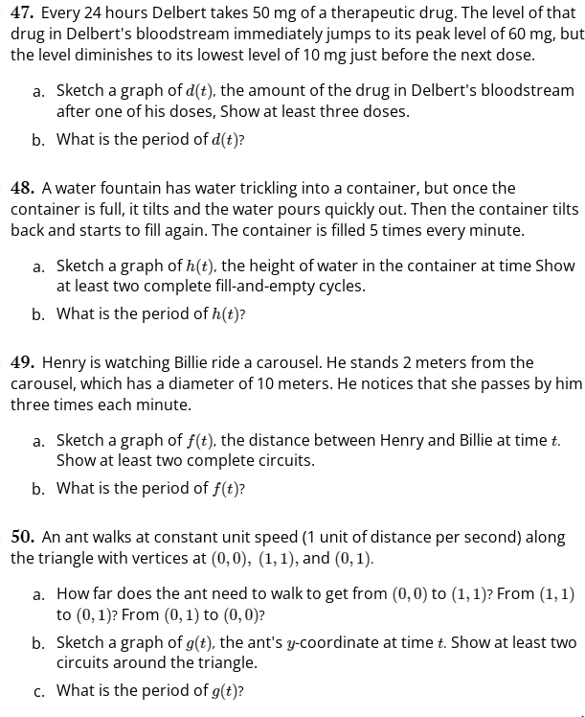

**FM 10.1:**

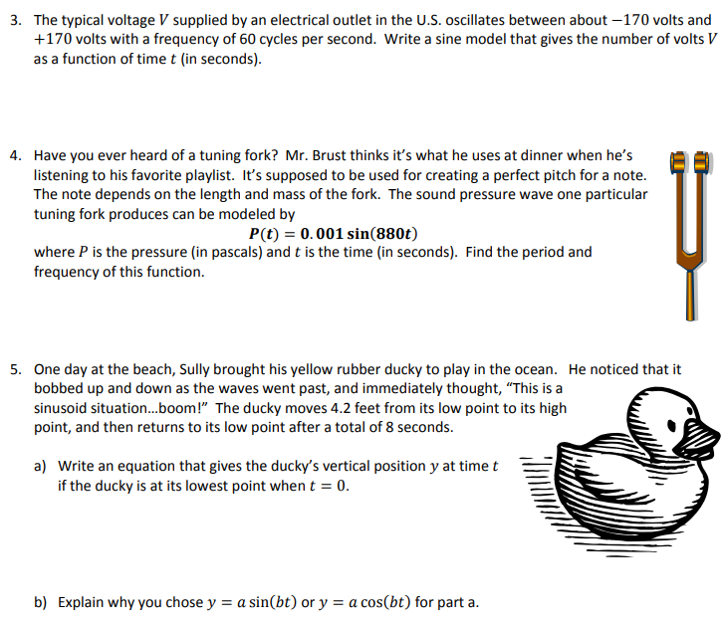

**10-2 Trig Functions**

**Yoshiwara 7.1:**

**7.9:**

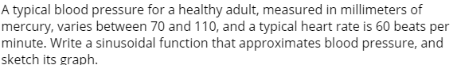

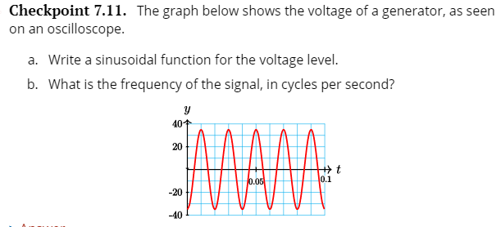

**7.1 HW;**

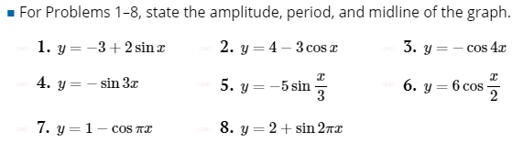

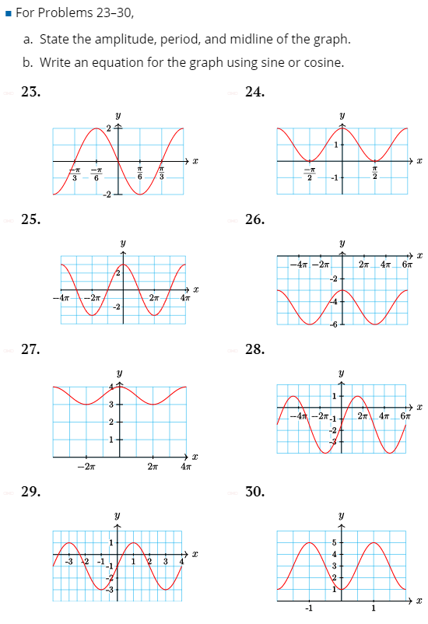

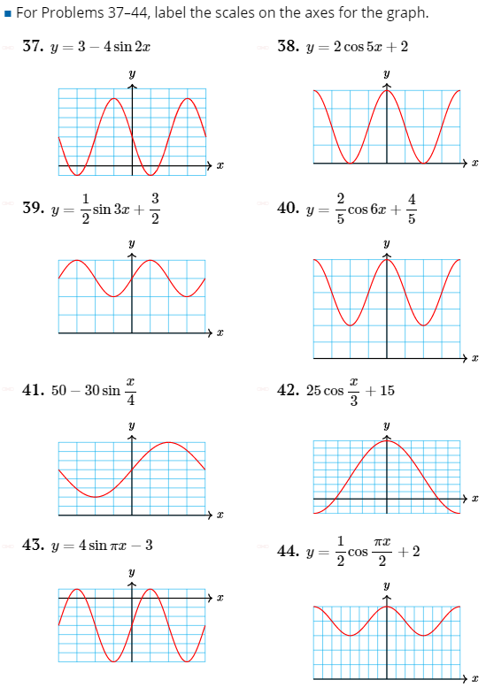

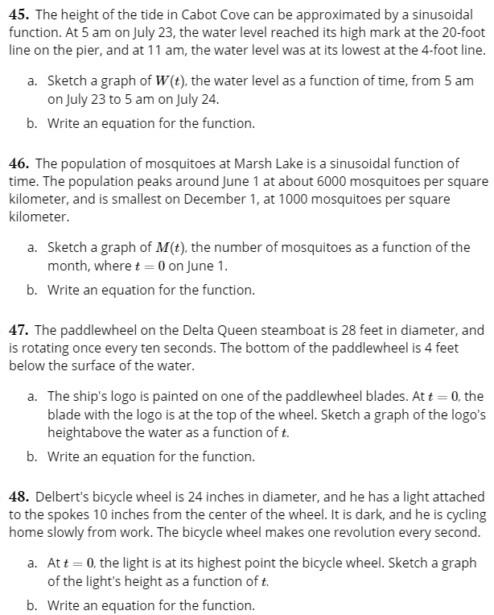

**7.2**

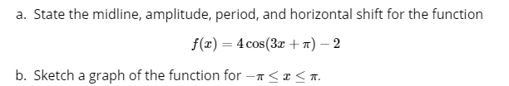

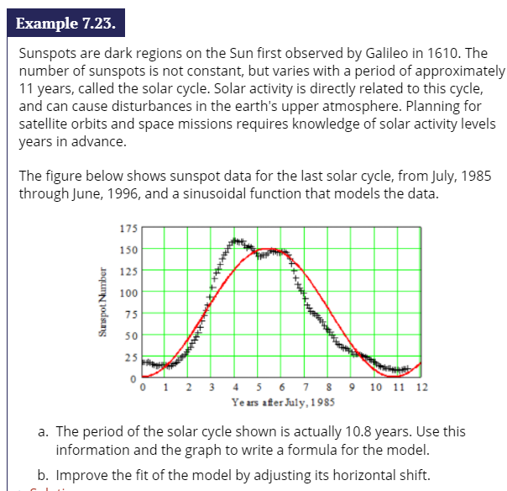

**7.2 HW**

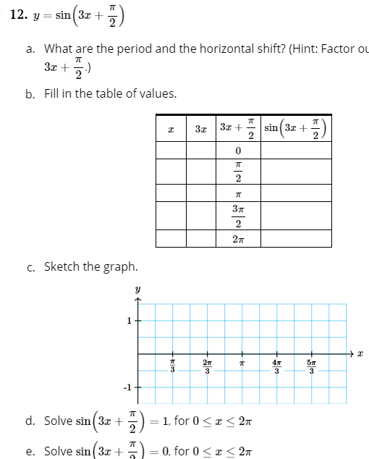

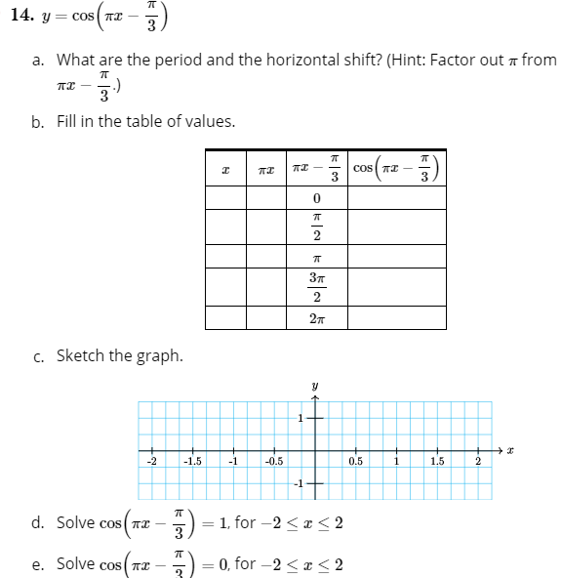

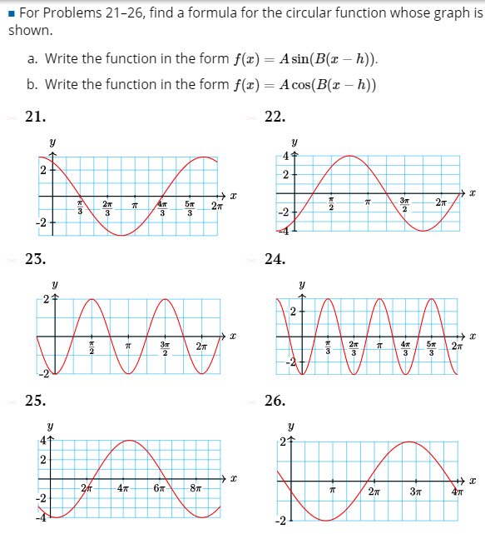

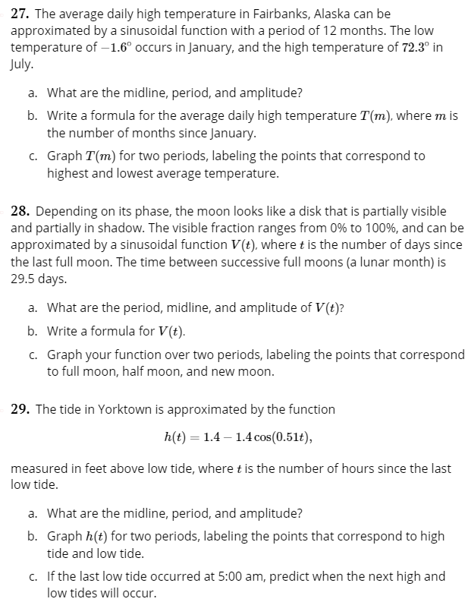

**FM: 10.2**

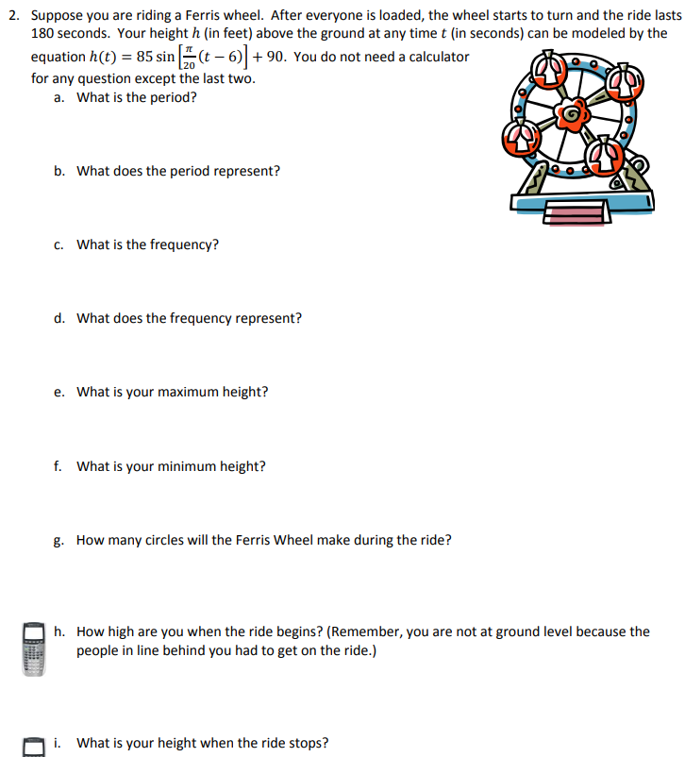

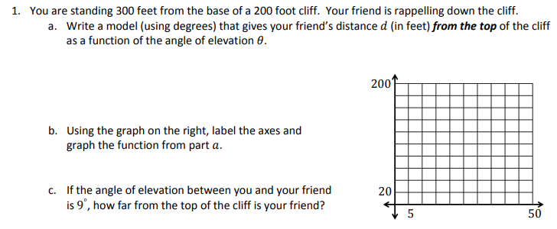

**S-Z 10.5:**

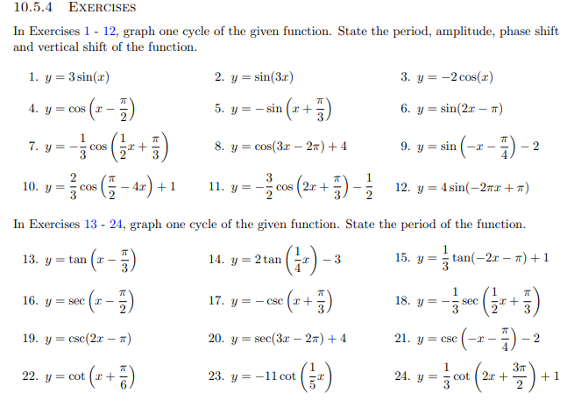

**Calc-Medic: 4.5**

1. Give a convincing argument for which of the four graphs doesn’t belong. Can you find a reason for each of the graphs?

|  |  |
| --- | --- |
| Chart, line chart  Description automatically generatedA | Chart, line chart  Description automatically generatedB |
| Chart, line chart  Description automatically generatedC | Chart, line chart  Description automatically generatedD |

1. The equation for the graph below is given by . Find the values of *A, B*, and *C*.

1. Which of the following equations is NOT equivalent to the other three?

**10-3 Applications of Trig/Solving Trig Equations (Make Equations to have “famous” answers)**

**Yoshiwara 5.2: All linear or quadratic in a trig function of single angle.**

**S-Z has a lot. P. 857. Also 11.1**

**Calc-Medic Units 4-5**

**S-Z**

**10.3 p. 764**

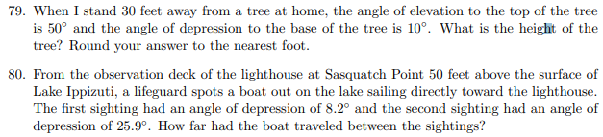

**p. 846:**

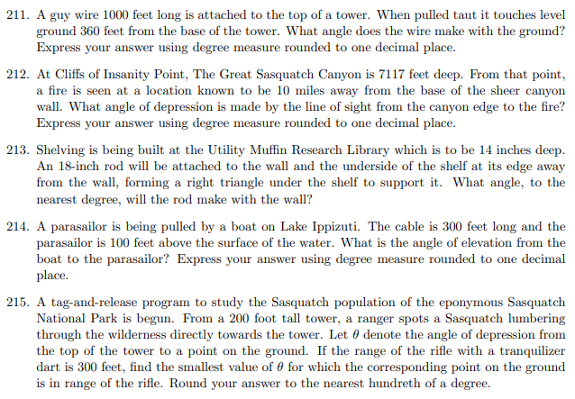

**p. 862:**

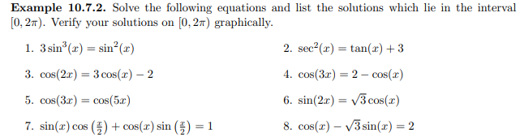

**p. 874:**

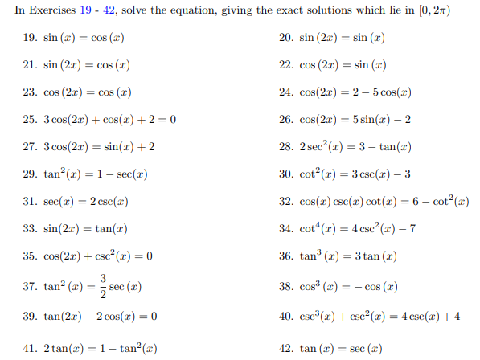

**p.891:**

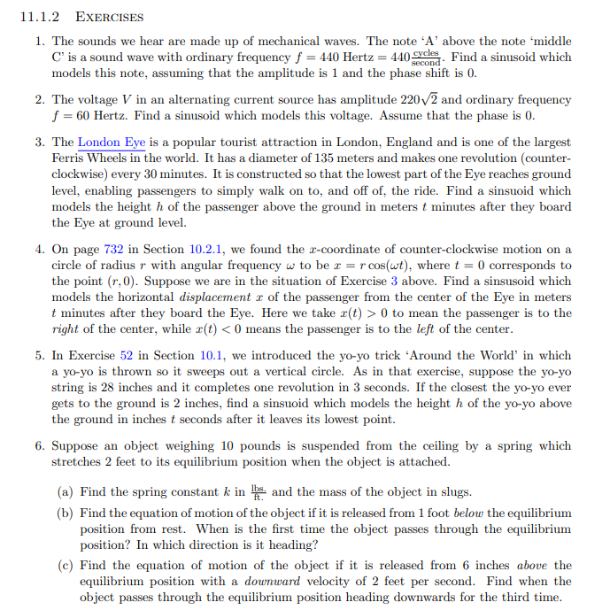

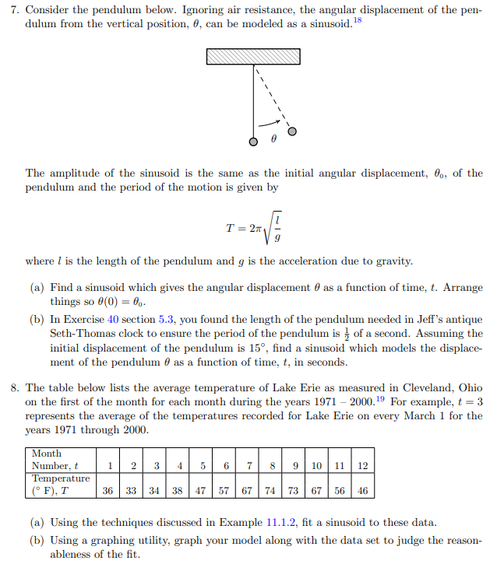

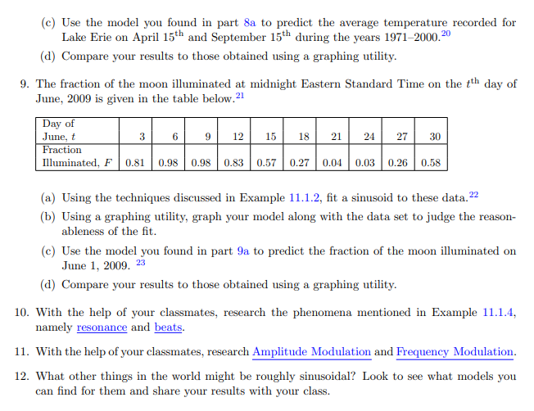

**Calc-Medic 4.8**

|  |
| --- |
| The temperature, in ˚Fahrenheit, outside a house during a 24-hour period is given by for . Time is measured in hours. *Note*: *all angle measures are in radians.* |



1. Find the temperature at , , and without using a calculator.
2. What is the highest temperature recorded outside the house? How do you know?
3. Would it make sense for to represent midnight? Why or why not?
4. Sketch the graph of .
5. Find the amplitude of . Explain what your answer means in the context of this problem.
6. Imagine if we used this model to predict the temperature over a 48 hour period. Describe what the model predicts would happen on day 2 (. Do you think this is reasonable? Why or why not?
7. The air conditioner turns on when the temperature is at or above 78˚. At what time, *t*, does the air conditioner turn on and when does it shut off again? How do you know?

Section 4.8—Trigonometric Modeling

|  |
| --- |
| Important Ideas: |

Check Your Understanding!

Patty decides to ride the Ferris wheel at the amusement park. Her distance above the ground (in feet) after *t* seconds is given by .

1. Explain why it makes sense that her distance is modeled by a trigonometric function.
2. Estimate her height above the ground after 5.5 seconds.
3. What is the maximum height that Patty is ever off the ground? What is the minimum height that she is ever off the ground (and why is it not 0?)
4. What is the diameter of the Ferris Wheel? How do you know?
5. How long does it take the Ferris wheel to make one complete revolution?